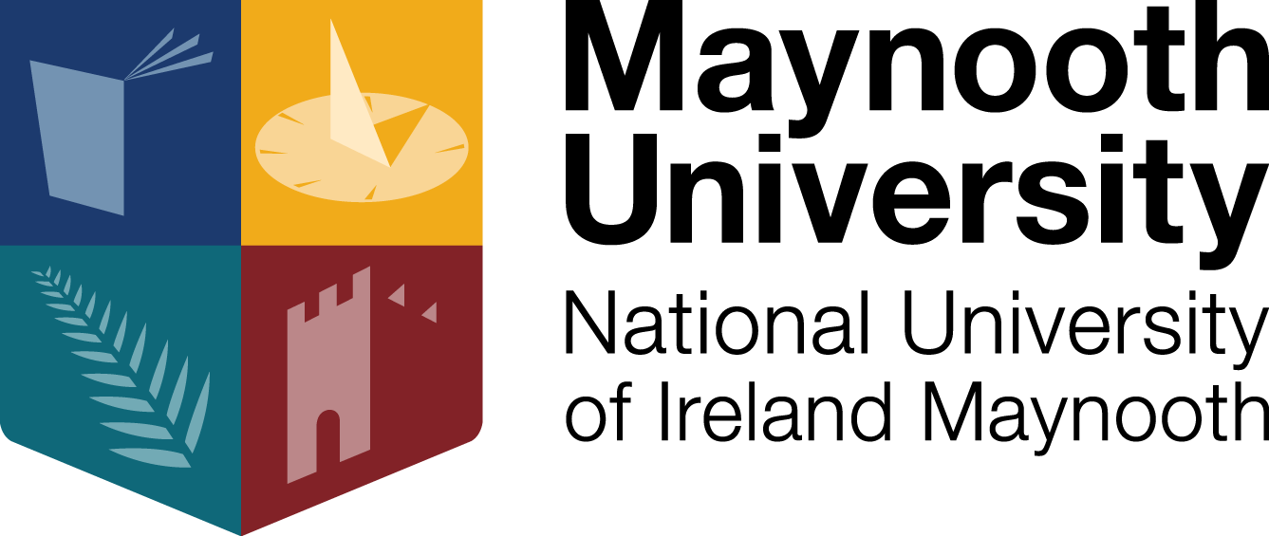

Ambient-BD - Maynooth University Research Team

Dr Lorna M. Lopez, Department of Biology, Maynooth University (Lead Investigator)

Professor Andrew Coogan, Department of Psychology, Maynooth University (Lead Investigator)

Dr Cathy Wyse, Department of Biology, Maynooth University (Senior Research Fellow)

Sean Farrell, Department of Biology, Maynooth University (Research Assistant)

Christiane O’Brien, Department of Biology, Maynooth University (Research Assistant)

Please visit the Ambient-BD project website to learn more about the rest of the Ambient-BD team members [https://www.ambientbd.com/ (https://www.ambientbd.com/)](https://www.ambientbd.com/)

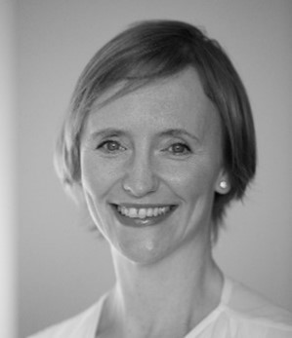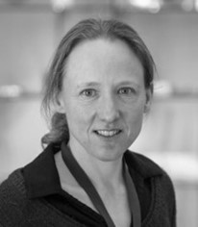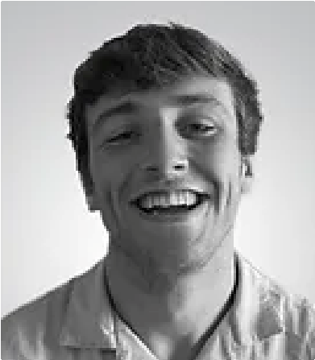

Dr Lorna Lopez Prof Andrew Coogan Dr Cathy Wyse Christiane O'Brien Sean Farrell

Please contact the team anytime if you would like more information about our research

Ambient-BD Research Team,

Department of Biology,

Maynooth University, Co. Kildare ambientbd@mu.ie (mailto:ambientbd@mu.ie)